

­

­

**MADE BY:**

**Money Makers**

**REPOSITORY:**

**Money Makers**

Table of contents

**MONEY MAKERS** 1

TABLE OF CONTENTS 2

PROJECT IDEA 3

TEAM MEMBERS 3

STAGES OF THE PROJECT 4

PERFORMED TASKS 4

BLOCK DIAGRAM 5

FUTURE IDEAS 6

Project idea: We wanted to be original and different from the others and then we remembered about one popular TV show

Team members

|  |  |  |  |
| --- | --- | --- | --- |
|  | **Name** | **Class** | **Role in the team** |
| **1.** | Martin Milenov Stoyanov | **9B** | **Scrum Trainer** |
| **2.** | Georgi Nikolaev Ivanov | **9V** | **Backend developer** |
| **3.** | **Teodor Dimitrov Tanev** | **9G** | **Frontend developer** |
| **4.** | Ivan Vasilev Andreev | **9A** | **Quality Assurance** |

Stages of the project

PERFORMED TASKS **✔**

|  |  |
| --- | --- |
|  | Performed tasks |
| 1 | Created the basic design of the game  It contains billboard with the question, road and life counter |
| 2 | Created a menu  It contains the name of the game and the empty map of the game . Also there are three options: START, RULES,EXIT |
| 3 | Created a Game Won menu  It says you “CONGRATULATIONS” and that you won 1500 BGN |
| 4 | Created a Game Over menu  It says you “GAME OVER” and that you won the money that the last checkpoint gives. |
| 5 | Created a Forfeit menu  It says you “You decided to give up and to get the money you collected until now” |
| 6 | Created README.md, Documentation, Presentation, QA table  They show how we have worked on the project |

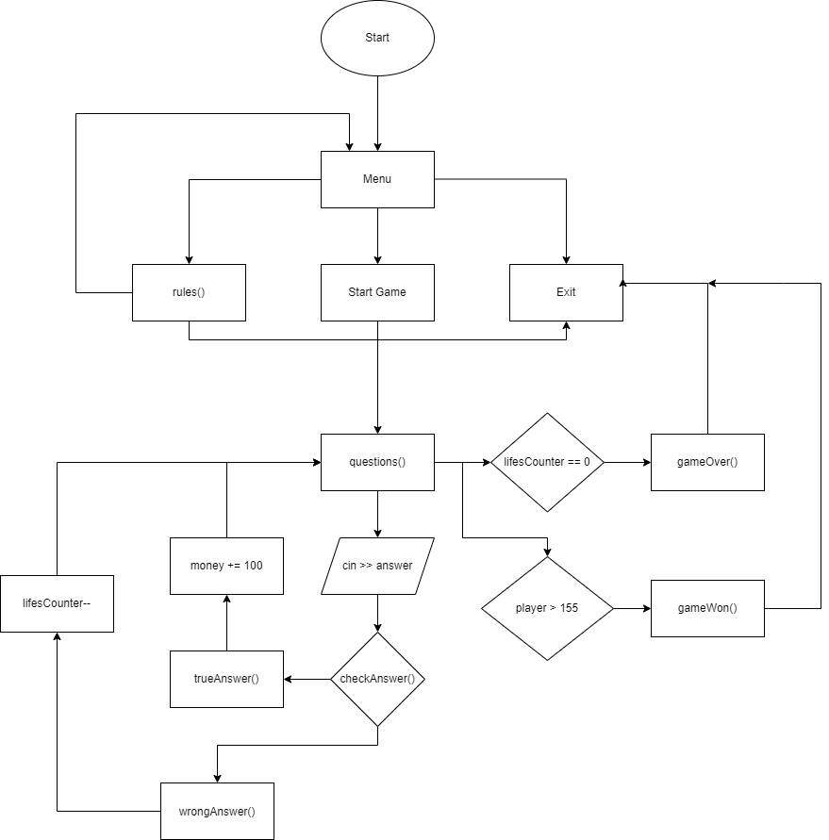BLOCK DIAGRAM

FUTURE IDEAS

|  |  |
| --- | --- |
| 1 | Create difficulties |
| 2 | Create more questions |
| 3 | Multiple choice questions which will be harder than these now |